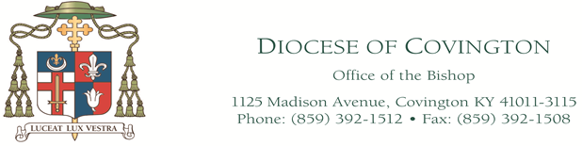

DECREE OF PROMULGATION

December 8, 2018

Dear Brothers and Sisters in Christ Jesus:

In 1995, during the World Youth Day event, Pope, St. John Paul II called the Church to become the “traveling companion of young people.”

My brother bishops took up the Holy Father’s challenges in the “Renewing the Vision: A Framework for Catholic Youth Ministry” by focusing the Church’s Ministry with adolescents on three essential goals:
1. Empowering young people to live as disciples of Jesus Christ in our world today; 2. Drawing young people to responsible participation in the life, mission and work of the faith community; and 3. Fostering the personal and spiritual growth of each young person. To accomplish these goals it will take all of us and all the resources we have in our local diocese.

Therefore, in light of the Renewing the Vision document, the Department of Catechesis and Faith Formation, in collaboration with the Diocesan Youth Ministry Advisory Board, are presenting this manual. Their mission in presenting this manual is that they want to invite parishes in the diocese to be traveling companions with our young people.

In this manual they present some tools that can help at the parish level with starting or maintaining youth ministry activities.

Much of the manual is very general however there is some very specific information concerning the proper way to conduct meetings, events and outings in or out of our diocese.

It is my hope that you find this information very helpful. Please feel free to make suggestions for improvements by directing comments to Isaak A. Isaak, Director of the Department of Catechesis and Faith Formation in the Diocese of Covington.

Their leadership and support in this important document is appreciated. Let us now continue to work with God’s grace to share the light of faith with our young people in a way that will lead them to the knowledge of God’s Truth, and to a living encounter with Jesus Christ.

In this Holy Year of Prayer for priestly vocations, on Saturday, December 8, 2018, the Solemnity of the Immaculate Conception of the Blessed Virgin Mary, I promulgate the manual, Youth Ministry: How to Create a Program in Your Parish, and urge pastors and youth ministers to implement and utilize this tool in the most appropriate manner in each parish.

Yours Devotedly in the Lord, 
Most Reverend Roger J. Foys, D.D.
Bishop of Covington

Diocese of Covington
Department of Catechesis and Faith Formation

Youth Ministry: How to Create a Program in Your Parish

The publication of Youth Ministry: How to Create a Program in Your Parish has been a combined effort of the Department of Catechesis and Faith Formation, in collaboration with the Diocesan Youth Ministry Advisory Board.

This three year project involved the study of the National Federation for Catholic Youth Ministry and the Archdiocese of Baltimore’s Division of Youth and Young Adult Ministry entitled, Groundbreaking: A How-To-Guide for Building a Comprehensive Youth Ministry Program.

The following people have contributed to the revision and updating of this program to better suit the needs of the Diocese of Covington.

Mr. Isaak A. Isaak
Director, Department of Catechesis and Faith Formation
Diocese of Covington

Rev. Mr. Peter Freeman
Assistant Director, Dept. of Catechesis and Faith Formation
Diocese of Covington

Mrs. Marian West
Secretary, Department of Catechesis and Faith Formation
Diocese of Covington

Chairperson Mrs. Michele Garvey
Assistant Director of Religious Education
Blessed Sacrament Parish, Fort Wright

Staff Members, Dept. of Catechesis and Faith Formation

Maggie Grady Spears
Secretary and Event Coordinator
Dept. of Catechesis and Faith Formation
Diocese of Covington

Brad Torline
Coordinator of Young Adult Ministry,
Dept. of Catechesis and Faith Formation
Diocese of Covington

Contributors

Mrs. Sharon Brown
Parishioner, St. Henry Parish, Elsmere

Mr. Paul Dierig
Youth Minister, St. Timothy Parish, Union

Mrs. Susan Stewart
Youth Minister, St. Mary Parish, Alexandria

Mrs. Tina Klare
DRE/Youth Minister, St. Joseph Parish, Crescent Springs
Mrs. Mary Kay Laird
Parishioner, Blessed Sacrament Parish, Fort Mitchell

Mrs. Sheila Gray
Teacher, Covington Latin School, Covington

Deacon Gerald R. Franzen
Deacon, Cathedral Basilica of the Assumption

Ms. Amanda Chapman
Parishioner, Mary Queen of Heaven Parish

Youth Ministry: How to Create a Program in Your Parish

Department of Catechesis and Faith Formation
Diocese of Covington
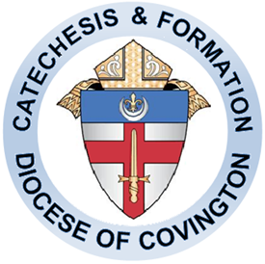

Table of Contents

- Youth Ministry Basics 1
- Youth Ministry Teams: Important Agenda Items 5
- Key Roles in Youth Ministry Programming 13
- Gathering Young People: Publicity and Outreach 15
- Getting Started: A Town Hall Meeting 17
- Basic Resources 19
- Appendix 21

Youth Ministry Basics

Definition
Three primary goals in our ministry to young people are:
- To empower young people to live as disciples of Jesus Christ in our world today.
- To draw young people to responsible participation in the life, mission and work of the Catholic faith community.
- To foster the total personal and spiritual growth of each young person.

Components
- Advocacy
- Catechesis
- Community Life
- Evangelization
- Justice and Service
- Leadership Development
- Pastoral Care
- Prayer and Worship
Underlying Assumptions for a Comprehensive Vision
- Developmentally Appropriate
- Family Friendly
- Intergenerational
- Multicultural
- Community-wide Collaboration
- Leadership
- Flexible/Adaptable Programming

Ten Steps in Planning Youth Ministry

This approach to developing youth ministry utilizes a team of interested adults and establishes a structure for assessing the needs of young people, designing appropriate programs as responses to their needs, and fosters an ongoing planning and evaluation process.

Step One: Get the Right People Together

The first step is developing a team for the youth ministry program. The team should include adults who can be good role models, who are comfortable sharing their faith with youth and who like young people. The team should include a member of the parish staff if possible (pastor, director of religious education, pastoral associate, etc.). The team can also include selected young people who have demonstrated initiative, interest, and leadership abilities. The key is to avoid the “Lone Ranger” trap. Youth ministry is a team effort. It is also important for someone to serve as the team coordinator. A more formal coordinator can be chosen later, if necessary. In the early planning stages, someone must facilitate the group and provide leadership. Consider the following:

- Who should be on the youth ministry team?
- Who will facilitate the team meetings?
- Who should serve as coordinator?
- How do we gain support of the parish staff?

Step Two: Understand Your Goals for Youth Ministry

The overview of youth ministry presented in the introduction could be distributed and used as the basis for a team discussion. Be sure to begin each planning session with prayer, praying for young people and their needs, and for the willingness of the parish to welcome young people. The team needs to spend time clarifying their vision of youth ministry by considering the following:

  - What is our vision of youth ministry?
  - What do we want to accomplish?
  - What do we want to provide the youth of our parish?
  - Does our team have a holistic and comprehensive approach to ministry to young people?

This is a time for building team relationships and developing good communication within the group. The team should also discuss whether the program is for junior high, senior high, or both. This decision will affect the style and type of programs to be developed.

Step Three: Conduct a Needs Assessment

Past and current programs should be assessed after the parish youth have been consulted. Once this information has been gathered the team can then look at past and current programs to see if any aspects of these programs are already meeting those needs or can be slightly modified to better do so.

  - What will our team do to assess the needs, interests and concerns of our young people?
  - Who?
  - When
  - How?

Step Four: Past Programs and the Current Situation

Assess how the past and current programs have met current needs in the past, are meeting needs in the present, and how effective and/or adaptable these programs will be in the future.

  - What’s been done in the past?
  - What’s going on right now?
  - Do we have adolescent catechesis?
  - Confirmation programs?
  - Catholic Scouting?
  - Athletics?
  - Do we have a Catholic school?
  - Have there been problems in the past?
  - What worked and what did not work?

Step Five: Brainstorm Program Activities and Ideas

Based on the needs from the assessment and the review of past and current programs, it should be easier to identify “holes” in youth programming and find ways to fill in the gaps. Prioritize your ideas. Do not try all of your ideas at once. Begin by trying a few things, and do them very well. Plan for quality activities and do not evaluate solely on the number of participants. Good programs and publicity will attract youth. Go for the short term, immediate successes at first. Then plan for the long term. Do not plan more than your team can actually do.

  - What are our top five ideas?
  - What are our time and personnel limitations?
  - How can we bolster our team effort?

Step Six: Develop the Ideas into Actual Programs

Good planning always answers the who, what, when, where, and how questions. (See the sample event planning form in the Appendix.) Plan a variety of program formats, times, and content. Plan activities that youth want. Gather youth ministry resources for planning (see Appendix). Plan well and advertise your event. Use flyers in the schools (if allowed), a newsletter sent to each parish teenager, personal phone contacts, the parish bulletin, the parish website, and posters around the parish. Be creative and always over-publicize.

  - Have we answered all the basic planning questions?
  - Have we planned for good publicity?
  - Have we considered refreshments?
  - How do we respond to positive or negative responses?

Step Seven: Develop a Youth Ministry Calendar

It might be easier to plan in seasonal or three month blocks. Don’t forget that the summer is an important time for programming, especially for younger adolescents. In planning, try to achieve a balance of programs among the eight components of comprehensive youth ministry. Check with the parish and local high school calendars, so you are not competing for your teens’ time. Also check the diocesan office of youth ministry calendar. There are frequently events taking place that your young people can attend. It makes planning easier and promotes early success. You should also consult with surrounding parishes to see if they have activities your young people can attend. It is good for teenagers to see what others are doing and it helps them experience a larger sense of church.

  - Have we checked the diocesan, parish, and school calendars?
  - Do we have our activities spread out over the next few months?

Step Eight: Assign Responsibilities and Leaders

It is important to enable young people to take some responsibility for the program activities. Early in the process, however, adults should provide the leadership if the youth are not ready for the responsibility. Each activity should have a leader or co-leaders with a teen and adult together. This leadership could come from the planning team for the particular event. Try to recruit young adults or younger teachers to help as you start your youth group. Parents can be very helpful, but often teens appreciate having an activity to call their own.

  - Do we have a planning team for each activity?
  - Do we have a person assigned to each task?
  - Have we discussed an appropriate role for youth?
  - Is the team building confidence in itself by doing positive things for parish youth?
  - How are young people being included in implementing and leading activities?
  - How are we praying as a team for each activity?

Step Nine: Develop an Organizational Structure

An organizational structure provides the ongoing leadership and coordination needed for a comprehensive youth ministry program. The structure can vary according to the members and needs of your team. Program committees with youth and adults, a coordinating team, a youth board and adult advisory board are all options for your organization. Use the structure that will work for your team. Also, it is important to determine regular meeting times for the committees, team, or board and to identify the person who will coordinate the group, set agendas, and facilitate the meetings.

  - What structure will we use?
  - How often will our coordinating team meet?
  - Who will facilitate the team meetings?
  - Who will take minutes of the meeting?
  - Who will set the agenda?
  - How has time for reflection and prayer been incorporated into planning sessions?
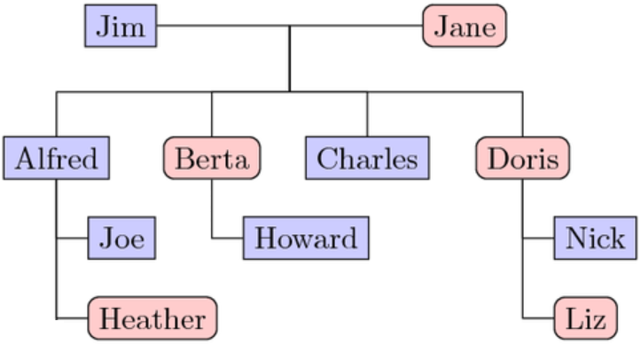

Step Ten: Planning and Evaluation Process

As part of your calendar of events, schedule the times when this group will re-assess the situation and plan for the upcoming year. Planning is an ongoing and intentional process and includes opportunities for team building and social times. You might use spring as the time for new needs assessments and program calendaring, and June as time for the annual evaluation. Your planning will begin to incorporate some traditional events (things done every year; e.g., a Christmas social or Lenten Stations of the Cross), spontaneous events (spur of the moment activities; e.g., a trip during a sudden school holiday or a food drive in response to a natural disaster) and a cafeteria approach (variety of activities which allows youth some choice for participation). The team should also begin planning for leadership training for both youth and adult team members.

  - When will we evaluate our year?
  - When will we plan for the upcoming year?
  - What opportunities for youth and adult training are available?
  - Do we need outside consultation from the diocesan youth office in the evaluation process?

It is important to keep in mind that these are very general guidelines and may not apply to every parish or situation. Smaller parishes will have entirely different goals and resources than large parishes. In using this guide, evaluate what steps apply to your situation. You may have a committee of one or a large group working on many different projects at once. The goal is the same: engage our youth in their faith.

Youth Ministry Teams: Important Agenda Items

In addition to the tasks of planning, implementing, and evaluating the youth ministry program, the team must also consider several other important issues that affect both the planning process and the life of the team.

Nurture Community among the Team

Youth ministry requires that the team model the type of community it seeks to establish among young people. Take care to plan time for the team to work at getting to know and understand each other. Perhaps a retreat day just for the team is feasible. Do not be so anxious to get to the actual building of the program that you might overlook this essential step. Times for prayer, community building exercises, and opportunities to enjoy each other’s company should be included on the agenda. Even after the team has been established, community building opportunities, especially prayer, should be continued. Remember too, that whenever new members join the team, time must be taken to re-build/re-enforce the team’s community.

Youth Protection and Safety Issues

There are certain items dealing with youth protection and safety that should also be addressed with the planning team before each event. All policies and regulations regarding child and youth protection issues must be followed to ensure the safety of young people in your programs. Coordinate these efforts with your parish Virtus Coordinator and Business Manager.

All volunteers must be Virtus compliant which includes background checks every five years, completed Virtus training and being up to date with all training bulletins. It is necessary to check annually that all volunteers remain up to date on their training. Also, check prior to any overnight events and trips to insure compliance of chaperons.

Transportation Guidelines

All trips that involve transportation must adhere to diocesan and parish policies. It is advisable to consult these policies for the most complete information to ensure a safe trip.

Encourage the use of public transportation or buses. If personal transportation is used, drivers must complete Form F: Driver Information Sheet and submit it in advance of the event. Anyone driving a non-relative must be 21 years of age.

Permission Forms

All activities held outside the parish and all activities that include an overnight require a permission form. The permission form should include information for the parents/guardians outlining the program and noting emergency phone number should accompany a permission form. Permission forms are intended to:

- Seek permission for the young person to participate
- Express the intention of the youth ministry team to provide adequate and responsible supervision
- Get important information regarding where parents can be reached during the activity
- Get important information regarding medical insurance coverage for the young person
- Get the parent’s permission to obtain medical assistance in the event that the parent cannot be contacted

Note: it is not appropriate to use one permission form for the entire year or even several different types of activities. It may be acceptable for the permission form to cover multiple meetings for the same activity, for example, a four-week Bible study, or eight-week peer ministry training. Check with the diocesan office for requirements on permission forms. See samples of all the permission forms at the end of this manual.

Guidelines for Adult Supervision

Determining the number of adults needed for supervision of adolescents depends on a number of factors: the nature of the activity, the age of the adolescents, and the location of the activity. All activities require a minimum of two Virtus trained adults age 18 or older. Unless the group being supervised is either all boys or all girls, it is recommended that there be a chaperon of each gender. Looking at the ratio of adults responsible for supervision to adolescents, overnight activities require a minimum of one adult for every eight young people. Some activities such as bowling or a dance at the church may allow a greater adult/youth ratio. An activity at an amusement park may require less supervision if the group is high school age as opposed to a group of middle school students. It may be appropriate to provide a constant supervising presence for younger and/or less mature adolescents.

Proper supervision does not always require constant presence. Periodic contact is sufficient in most situations. (Of course this must be balanced by the realization that building relationships between youth and adult leaders requires more than periodic contact.) In cases where risk is greater due to the nature of the experience, constant presence may be appropriate (for example: white water rafting or rock climbing). At all times, youth should be aware of the quickest way of reaching their adult and at no time should youth be unable to do so. It is inappropriate for adults to drink any alcoholic beverages while supervising a youth activity.

Examples of when to use forms: (See Appendix for Forms)

Form A: Small local events
Form B: Short form for adults
Form C,D: Local overnight
Form C,D,E: Overnight out of town
Form G: General adult permission form

All forms referred to in this section can be found on the Diocesan website:
http://www.covdio.org/catechesis-formation/youth-ministry/diocesan-forms-for-youth-ministry/

Guidelines for Disclosure and Reporting

Volunteers should have a clear understanding of the difference between counseling and guidance. The youth ministry planning team should develop a good list of referrals for counseling and youth at-risk services. Youth ministry coordinators, unless certified as a counselor, are not governed by public laws regarding disclosure. Young people should understand that a youth minister, either volunteer or professional, is not restricted by law from disclosing information to parents, public authorities, parish staff or counseling services. On the other hand, youth ministers need to respect the trust that a young person exhibits when he or she confides in an adult leader. Some basic guidelines are these:

- Always encourage parental involvement in reaching a solution. Parents have the primary responsibility for their children and failure to respect that responsibility can lead to difficulty. Where appropriate, coach a young person on how to approach their parent or guardian. In some instances, it may be necessary to accompany a young person when talking with their parents. Interceding for a young person by speaking with their parents before a meeting of the parents and young person is also an option.

- Involve a third party to use as a sounding board for your discussions and follow up actions with the young person. Using a third party as a sounding board is especially important in situations where it is inappropriate to contact the parents. Remember in cases of abuse, the diocesan Victim Assistance Coordinator should be notified (859-392-1515) and state law requires that the police should be contacted.

- Be on the lookout for life threatening situations: suicide, substance abuse, runaway, sexual abuse, or other physical harm. See the appendix for the appropriate agencies to contact in these emergencies. Youth ministers should be aware of the warning signs of these situations. Failure to respond to a detected life threatening situation may be perceived as negligence.

- Encourage professional counseling where appropriate. Be willing to assist the young person in setting up the counseling appointment, and getting to the counseling session. It is helpful to remain in contact, offering support to the young person while they are participating in the counseling. Counseling is available through the Diocese of Covington Catholic Charities office: 859-581-8974.

Overnight Accommodations

The following policies should be adhered to for overnight trips. In general, there should never be mixed gender gatherings in the sleeping areas. Whether you are camping in tents, using a retreat house, or hotel rooms, boys should never be in the girls sleeping area and vice versa. It may be appropriate to restrict any social gatherings in the sleeping areas.

While adults have supervision responsibilities, they should also observe restrictions about being in the sleeping areas of the opposite gender. With the exception of large dormitory sleeping accommodations (at work camp or on pilgrimage), adults and youth should never room or tent together.

When applicable, paid TV services should be turned off in the rooms.
Adults should continue supervision after lights out to ensure that young people are safe and where they belong. All-night supervision is not always necessary.

Alcohol Guidelines

It is out of concern for the safety and well-being of young people that youth ministry leaders must consult diocesan policies, parish policies and state laws regarding alcohol consumption in youth ministry settings. These policies typically recognize both our responsibilities for the supervision of young persons as well as the statutes of the state.

Alcohol Guidelines for Youth
Youth and young adults under the age of 21 who are under the influence of or consume alcohol at youth ministry events should be dismissed from that activity at the first opportunity. The parish and diocese reserves the right to restrict young people from attending future youth ministry events for underage drinking. When it is appropriate, young people who are in violation of parish or diocesan policies regarding alcohol, they should be encouraged to seek counseling or support.

Suggested Alcohol Guidelines for Adult Youth Ministry Leaders
Adult leaders should not consume alcohol at any Catholic youth ministry event. On overnight events this restriction applies around-the-clock. This restriction includes the evening hours after the young people have gone to sleep.


Adult leaders should consider refraining from alcohol consumption whenever they are present with youth and participating in a youth to youth minister relationship. Examples include a youth minister who goes for pizza with young people after an event, or attending a graduation party at the home of a young person.

Adult leaders who provide or assist youth in obtaining alcohol for their consumption will be dismissed immediately and are subject to state laws in this regard. Adult youth ministry leaders should inform the parents of any young person who has consumed alcohol. Parents have a right to know. This is in keeping with our partnership with parents.

Recommended Alcohol Policies for Parish/School Events with Youth
Gatherings that are primarily youth oriented should not serve alcohol. (For example, basketball awards ceremonies.)

Parishes or schools that sponsor events for intergenerational audiences where alcohol will be available should:

- Have the responsibility to ensure that no under-age drinking will be allowed.
- Make sure that parents of youth are aware that alcohol will be available and or served.
- Act to ensure that responsible drinking is modeled for the young people present.

An underage person should never be placed in the position of tending bar or serving alcohol. Parishes or schools should make it their responsibility to remind parents of the danger of allowing under-age youth to consume alcohol in their home.

Smoking Policy

No youth under the age of eighteen are permitted to smoke at diocesan gatherings. No one (young person or adult) is permitted to give, lend or sell tobacco products to a minor. Anyone who sells, loans, or gives tobacco products to a minor is in violation of the law.


Guidelines for Adults Who Smoke
While smoking is prohibited in many public places, adults are free to make choices about using tobacco products. Adults are encouraged to consider their sphere of influence when considering smoking at youth events. This would keep adults in greater solidarity with young people.

Consider the Total Youth Ministry Effect

In planning your parish youth ministry program, you should be thinking larger than a youth group. Total parish youth ministry includes many opportunities for youth. Parish sponsored Boy Scout and Girls Scout units are a common alternative for youth activities. Many parishes have athletic associations that sponsor youth teams in diocesan or recreation council leagues. A total parish youth ministry program should have some intentional outreach to parents of adolescents. An evangelization and outreach program that encourages youth participation might be an important part of parish youth ministry. All parishes must offer adolescents opportunities for continued catechesis beyond confirmation preparation.

Adolescent catechetical efforts can include free standing weekly, bi-weekly, and monthly programs, retreats, lock-ins, Scripture study, and a variety of other models. The youth ministry team should address the faith themes listed in the Youth Basics section at the beginning of this document.

Beyond these different program possibilities, a comprehensive parish youth ministry should work with other parish organizations to encourage and enable them to include youth in their ministry. Youth can and should have a role in many different parish programs such as: the liturgy committee, justice and peace committee, outreach and service programs, planning teams for the parish activities, lectors, music ministry, vacation Bible school, etc.

Another facet of the youth ministry picture includes reaching out to special needs youth. Where possible, include special needs youth in your programs. If you have a large enough group, you may consider having some events specifically for special needs youth.

Please realize that no parish can start with all of this. But it is important that the vision you start with includes the big picture. Remember not to limit yourself by thinking that parish youth ministry is the youth group.

Plan for Ongoing Training

Once a team has been assembled, it seems that every parish is anxious to get a youth ministry program up and running. Certainly, it is important to get some positive things accomplished while the group’s energy is high. But do not forget to plan for training. Successful youth ministry never happens by chance. Skilled leaders and committed volunteers require initial and ongoing training. Check the ongoing classes offered by the diocese through the Office of Catechesis and Formation.

Plan for Advocacy within the Parish

Remember that not all parishioners agree on the importance of youth ministry. For that reason, it
is important to keep the parish and the pastor aware of what is happening. Use the parish bulletin to advertise upcoming events and to thank key leaders for their work on past successes. Make regular reports to the pastor and/or the parish council. If the parish has a newsletter, make sure you include news about the good things that young people in the parish have accomplished. Because there are some adults who have a negative image of adolescents, it is important to help the parish learn about the positive impact that youth have in the community. Take advantage of your parish or school website, and their social media pages such as Facebook or Twitter. Every mode of communication will reach a different audience.

Prayer

Prayer should be the first item on all meeting agendas. Prayer brings the team together and establishes a common ground on which to build youth ministry. Take the time to be creative with the prayer experiences. Do not be afraid to spend 15-20 minutes of the meeting in prayer. Utilize different forms of prayer, especially prayer that allows the team to share their faith or their vision of ministry. Prayer works best in bringing the team together when all members of the team take turns in planning the opening prayer. Utilize your resources. Where possible, the team might come together for Mass prior to the meeting. Be sensitive to the many different styles of prayer that members of the team prefer and make it known that all styles are welcome. Young people will learn to pray better when the adult team models good prayer habits.

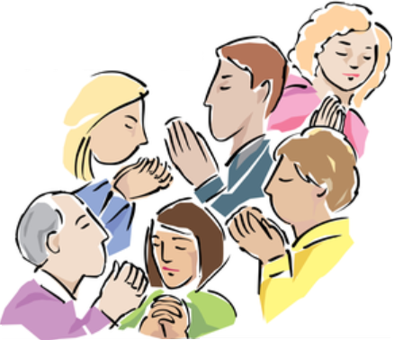

Key Roles in Youth Ministry Programming

Every parish is different in size, age, location and activity. This section gives some ideas on how a youth ministry program can be structured. Each parish will have to evaluate and determine what is feasible for their community. Certainly many hands make light work, but there should be a chain of command and definition of various positions.

Coordinator of Youth Ministry

This role is crucial for providing coordination for a parish’s youth ministry efforts. This person can be full time or part time, salaried, volunteer, or receive a stipend. It is not the function of this person to be the youth ministry in the parish. It is this person’s responsibility to enable and help grow the parish’s ministry to young people. Five key areas for the coordinator to focus their attention on include:

  - Direct Programming
  - Seasonal Programming
  - Leadership Development
  - Sacramental and/or catechetical programs
  - Administration

Essential tasks of the coordinator include:

  - Coordinate the parish’s ministry to young people
  - Facilitate the youth ministry team in its efforts
  - Serve as the liaison with the parish council and/or the pastor. Coordinate the recruitment, training, support, and evaluation of volunteers in the youth ministry program
  - Provide resources (print, video, training opportunities, diocesan events, etc.)
  - Advocate for using Renewing the Vision: A Framework for Catholic Youth Ministry in the parish

Youth Ministry Team

Youth ministry is a team effort. The team usually consists of committed adults and young people, many of whom are involved as program or activity leaders. Sometimes there is an adult advisory committee that oversees the youth ministry efforts and provides resources and direction. The planning team itself handles the practical implementation of the program. Sometimes the function of the advisory committee is absorbed into the planning team. Regardless of what model is utilized, the planning team has the following tasks:

  - They are responsible for needs assessments, setting goals and objectives, and designing programmatic responses
  - They handle the planning, implementation, and evaluation of the designed program
  - They watch for holistic programming, which might include the following: scouting, sports, adolescent catechesis, confirmation, parent involvement and programs, justice and service activities
  - They foster the involvement of young people in the life of the parish, including serving on various parish committees and being involved in parish activities

Program and Activity Leaders

These individuals have the responsibility for specific areas or activities within the total youth ministry program. Their responsibilities include:

  - They have direct responsibility for the planning, implementation and evaluation of critical areas within the program, for example: confirmation coordinator, justice and service coordinator, parish sports program director, youth group coordinator, scoutmaster, etc.
  - They have direct responsibility for specific activities, for example: catechists, coaches, scout leaders, youth group advisors, trip leaders, etc.

Chaperones

This important role is often where the relational dimension of youth ministry is most evident. These individuals provide the necessary supervision and involvement for programs to exist. Their tasks include:

  - Provide a consistent adult presence at youth ministry activities
- Provide appropriate supervision, as outlined by the planning team and/or coordinator
- Interact with the young people, developing relationships of respect, trust and care
- To not just serve as drivers or guards; their role is to build relationships with the young people
- Remember that all chaperons must be Virtus certified and compliant

Gathering Young People: Publicity and Outreach

How to reach young people and get them to participate in activities:

Hospitality

The youth must feel that they are a priority, valued, and welcomed by the parish. To accomplish this, the adult team must show hospitality by doing the following:

- Establish a consistent place such as a bulletin board close to the entrance of the church where youth announcements and photos may be displayed.
- Have a consistent header such as “We value YOUth” for youth information. Youth recognize this as their specific information. This can also be used for the adult team who works with the youth.
- Perhaps a youth section in a parish book rack could be set up with youth resources.
- At parish gatherings be sure to include food and drinks that youth like.

Presence is important.

Parishioners must convey that they want to be part of young people’s lives. This can be done by:

- Sending birthday cards to them (with no other agenda connected to the cards)
- Send newsletters to all youth in the parish
- Be present where the youth are: at their games, plays, at school day events, etc., and let them know that you are there from the parish to wish them well
- Send a special card to wish them well at exam time
- Be aware when they are present at funerals, baptisms, or a celebration and make appropriate contact with them
- Parishioners representing the parish can be present at community events.
- Place ads in high school play programs, sports banquet programs, or school newspapers with “Best wishes to....from … parish. We’re rooting for you and are proud of you” (or a similar message).

Publicity is important

Begin by asking, where are the youth in our community? How can we be present there? Are there other ways we can be present in the lives of young people in our community? How do we invite young people into our programs and make them feel welcome?

The following are just a few methods of advertising:

- Parish bulletin announcements
- Announcements at Mass
- Notices on the youth bulletin board
- Flyers at local school, sports, or social events, or ask schools to post notices.
- Mail newsletters, postcards, flyers, etc.
- Email
- Create a name and logo that is easily identifiable to associate with your youth ministry or for a particular event, and put it on all advertisements.
- Divide lists of youth phone numbers and make personal contacts.
- Ask your parish youth to invite friends or others
- Send word through regular channels of communication: religious education programs, confirmation programs, parish or regional Catholic elementary or high schools. At the bottom of youth ministry calendars you distribute, or on announcements, have this printed, “Post on Refrigerator or Bulletin Board”.
- Advertise in “bytes” (sound or visual)—short slogans, recognizable phrases, catchy artwork or video clips.
- Be creative in the ways you send the information.
- Plan your marketing strategy for each event.
- Have a blitz weekend when you make a big push to spread the word.
- Make your announcement look and sound attractive
- Begin promoting your event early enough that youth and their parents can add it to their calendars and not plan anything else on that date. For a smaller function, begin advertising the activity three to six months before the event. For a large function, start the promotion at least a year before the event.

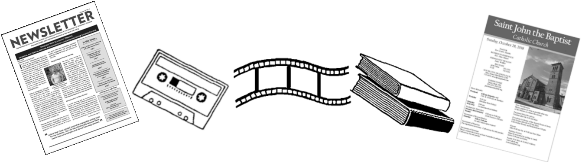

Getting Started: A Town Hall Meeting

Now that you have read what youth ministry is, what is should address, who should be involved, how to get the word out, and how to make sure you are in compliance with parish and diocesan policies—how do you begin? There is no single answer to this question, but below is information on how to plan for a sample meeting called a Town Hall. It’s a great way to gather a large number of people and get them excited about a new parish group.

Objective

The Town Hall Meeting is a gathering of young people primarily designed to get ideas and input about the activities, events, and programs they would like to see offered in the parish. However, the Town Hall Meeting is also an opportunity to build community among the participants and let them know of the parish’s concern, support, and interest in youth.

Description

The format should be adapted to local conditions, but there are several basic elements:

  - Welcome all who attend your meeting. As participants arrive have them sign in with name, address, phone number, e-mail address, school/grade, and birthday. Another option is to use the meeting flyer as a registration form, with spaces provided for the requested information. Ask them to bring the completed flyer with them to the meeting.
  - Have name tags for participants to use, and markers for them to write their names.
  - Pray at a designated time during your meeting. You should incorporate symbols, music, and readings appropriate for young people. The team might decide to begin the meeting with prayer, or instead to have prayer at the closing.
  - Prepare one or two ice-breakers and introductions.
  - Break into groups of 4-6 to brainstorm ideas for activities. Have individuals count off by the number of desired small groups, or use some other method for breaking into groups. Have a team member in each small group to facilitate the discussion. Begin with the participants sharing their name, school, grade, and favorite hobby. Having a suggested framework for the brainstorming activity would be helpful; e.g., using the eight components of comprehensive Catholic youth ministry: advocacy, catechesis, community life, evangelization, justice and service, leadership development, pastoral care, prayer and worship. Groups could identify activities for all the components, or each group could have one component.
  - Bring everyone back together as one group to share ideas. An option would be to prioritize the list of activities.
  - List the activities by writing them on large sheets of newsprint, using an easel. Have participants sign their name and phone number under the activity they would be interested in helping to plan. This is the beginning of your planning teams.
  - Provide refreshments with some social time, and announce the date of the next activity or gathering.

Materials Needed For the Meeting:

• Nametags (possibly with symbol or sticker for breaking into small groups)
• Ice-breaker materials
• Newsprint and markers
• Tape
• Refreshments

Planning Team Tasks

  - Locate a secure site and check for availability.
  - Check the parish census and send out personal invitations, place posters in the parish and schools (if feasible), have bulletin announcements and inserts, have the team make personal phone calls. Publicize the event as much as possible.
  - Decide on the ice-breakers, breaking into small groups, and handling the large group reports.
  - Gather the materials for the ice-breakers and small group process.
  - Purchase food and drinks.
  - Assign tasks to team members: registrations, publicity, prayer, welcome, ice-breakers, small group process, refreshments, and clean up.

The planning team should consist of six to eight youth and adults. There should be at least three to four planning meetings prior to your first gathering with the youth. After your meeting with the youth has taken place your team should come together to evaluate the meeting.

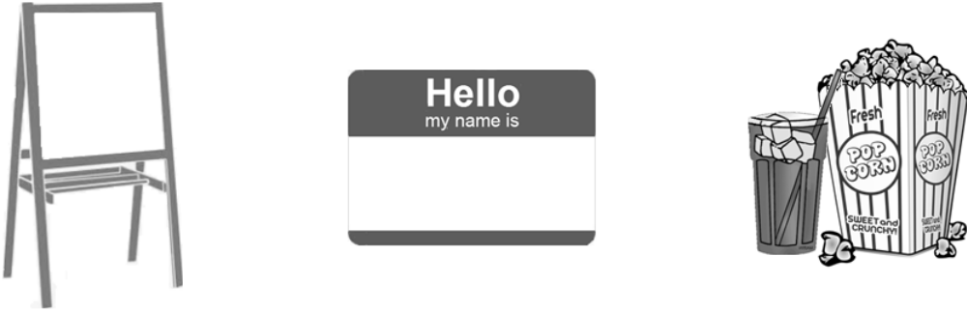

Basic Resources

The following are basic resources for your youth ministry library. Consider adding new resources in all areas of youth ministry as your program develops.

Youth Ministry Websites

While there are many websites that have much to offer in the area of Catholic youth ministry, we recommend the following as a starting point:

Catholic Campaign for Human Development, www.usccb.org/cchd/index.htm
Catholic Relief Services, www.catholicrelief.org
Center for Ministry Development, www.cmdnet.org
Cornerstone Media, Inc., www.cornerstonemedia.org
Disciples Now, www.disciplesnow.com
Group Publishing, www.grouppublishing.com
National Federation for Catholic Youth Ministry, www.nfcym.org
Saint Mary’s Press, www.smp.org
Search Institute, www.search.institute.org
United States Conference of Catholic Bishops, www.usccb.org
Youth Ministry Network, www.ymnetwork.net
Youth Specialties, www.youthspecialties.com

Youth Ministry Print Resources

There is a growing wealth of Catholic youth ministry resources. The following are offered as a starting point. These publications will assist the youth ministry team as they begin to give shape to a comprehensive youth ministry in your parish.

Michael Carotta, Sometimes We Dance, Sometimes We Wrestle: Embracing the Spiritual Growth of Adolescents, (Harcourt Religion Publishers, Dubuque, IA, 2001)

Doug Fields, Purpose Driven Youth Ministry: Effective Foundations for Transforming the Lives of Young People, (Zondervan Publishing Company, Grand Rapids MI, 1998)

General Directory for Catechesis, (United States Catholic Conference, Washington, DC, 1998, Publication No. 5-225)

FrankMercadante, Growing Teen Disciples: Strategies for Really Effective Youth Ministry, (St. Mary’s Press, Winona, MN, 2001, originally published by Ave Marie Press in 1998)

(Youth Ministry Print Resources, Cont.)

National Directory for Catechesis, Currently awaiting the final approval and publication of this document. See the USCCB website (www.usccb.org) for further information about this resource.

Youth Ministry Resource Manual, NFCYM publishes this yearly with ideas for each month along with tools for the local celebration of World Youth Day in your parish. See the NFCYM website (www.nfcym.org) for further information .

Renewing the Vision: A Framework for Youth Ministry, (United States Conference of Catholic
Bishops, Washington, D.C. 1997. English: Publication No. 5-004, Spanish: Publication
No. 5-005)

Promise to Protect, Pledge to Heal: Charter for the Protection of Children and Young People,
(United States Conference of Catholic Bishops, Washington DC, 2002, Publication
No. 5-540

The Total Faith Initiative, (St. Mary’s Press, Christian Brothers Publications, Winona, MN, 2004)
• Includes resources from Scriptures and Tradition
• 6 youth ministry resource manuals
• 4 catechetical manuals
• A coordinator’s manual
• CD-Rom

Youth Works (Center for Ministry Development, Nauguatuck, CT ,1996)
Over 200 programs and activities to create a vibrant ministry with older adolescents. Designed to implement Renewing the Vision: A Framework for Catholic Youth Ministry, the Catholic bishops’ pastoral plan for youth ministry. Contact CMD for further information at www.cmdnet.org
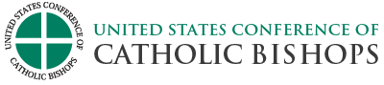

Appendix:

- Form A –Short form for youth – A joint medical and liability form for those outings which are one day and not out of town.
- Form B –Short form for adults – A joint medical and liability release form for those outings which are one day and not out of town.
- Form C –Youth Parental Consent and Waiver of Liability – This form should be used for most of the events sponsored by the parish or Diocese. It notifies the parents as to what the event is about. You should give as much information as possible about what is going to happen. You must have a newly signed Consent and Waiver of Liability for each event.
- Form D –Medical Emergency Form – This form needs to be NOTARIZED and is to be used for those events which take place outside of the Diocese or are considered to have possible risk involved. Ex. Work camp, canoe trip, NCYC, ski trip etc. This form is good for one year as long as the information does not change.
- Form E –Limited Power of Attorney for Health Care – This form is for all minor aged youth. It is to be used for all overnight events when parents/guardians are not able to be reached in case of an emergency. This form is used in conjunction with the Medical Emergency Form and gives the adult named the legal right to make health care decisions for the minor child in case of emergencies.
- Form F –Driver Information Sheet – This form is for those people who will be driving other youth to and from parish/diocesan events. All drivers must be 21 years old and have minimum insurance coverage listed on the form. (see also the Driver by parish form)
- Form G –Adult Consent and Liability Wavier – This form is for all adults who participate in parish or Diocesan events. A new form is to be filled out for every event.

If you have any questions about the use of these forms, please contact the Department of Catechesis and Formation, 859-392-1500 ext..1533 or email: mwest@covdio.org

Diocese of Covington: Creating a Safe Environment: Policies and Procedures for Creating a Safe Environment http://www.covdio.org/wp-content/uploads/2015/09/Policy2015.pdf

Phone Numbers to have on hand:

- Substance Abuse Hotline, the Northern KY Helpline: 859-415-9280
- Child Protection Hotline: 1-877-597-2331
- Poison Emergency: 1-800-222-1222
- Suicide Hotline: 1-800-273-8255
- For counseling, pregnancy, substance abuse: Catholic Charities, Diocese of Covington: 859-581-8974

Insert copies of Forms A,B,C,D,E,F and G*******

